**3. SYSTEM DEVELOPMENT**

The system developments consist of block diagram, circuit diagram, hardware and software description as following;

**3.1 Block Diagram:**

The block diagram consists of camera, proposed system which includes matlab simulation with microcontroller and power supply unit. The whole system works on a 5V or 9V dc regulated power supply..

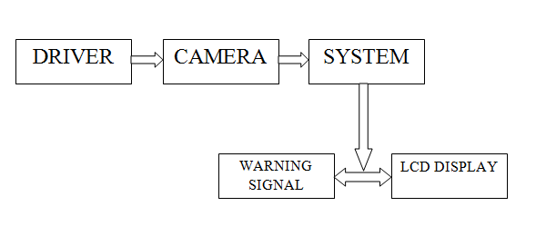

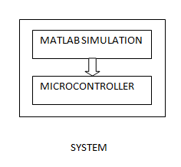

Figure 3.1: Block diagram of Drowsiness driver detection system